Oxford Sofa

Welcome to our shop !

Velvet Sofa

1. Green Velvet Sofa

**Price: $998.88**

Discover the perfect blend of form and function with our comfortable velvet sofa, a space-saving solution for modern living."

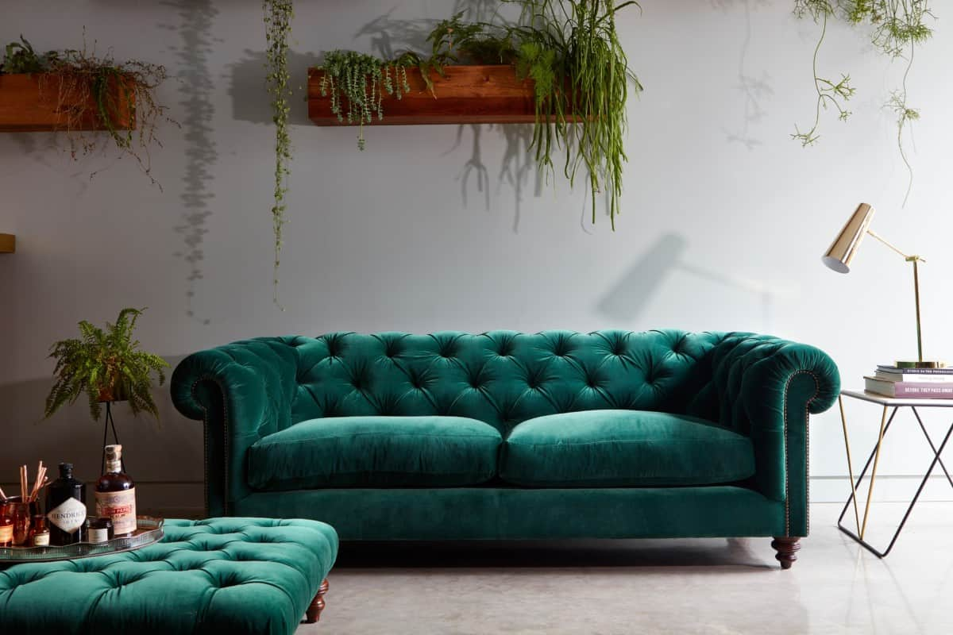

1. 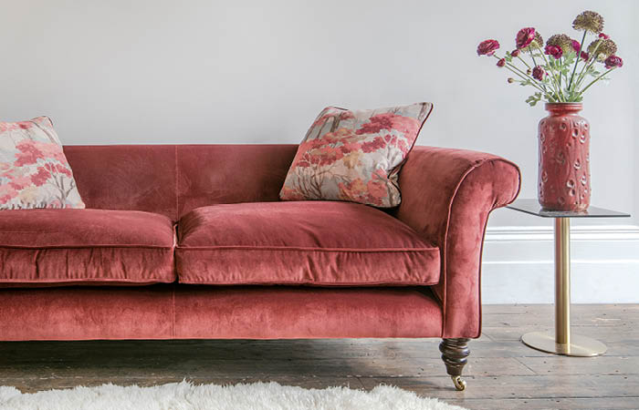Velvet 2 seater

**Price: $780.00**

Tailored for elegance, our tufted sofa adds a touch of sophistication to any setting.

Dee-wan Sofa

1. Elegant Green Dee-wan

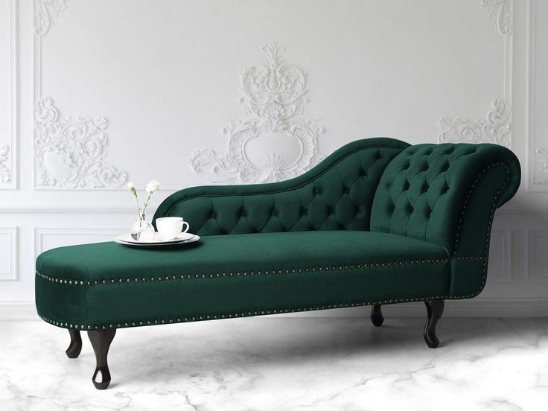

"Upgrade your space with a Chesterfield sofa, a timeless classic in modern upholstery."

**Price: $890.99**

4. 2 seater Dee-wan

**Price: $698.99**

Innovative and stylish, our reclining sofa offers personalized relaxation at its finest.

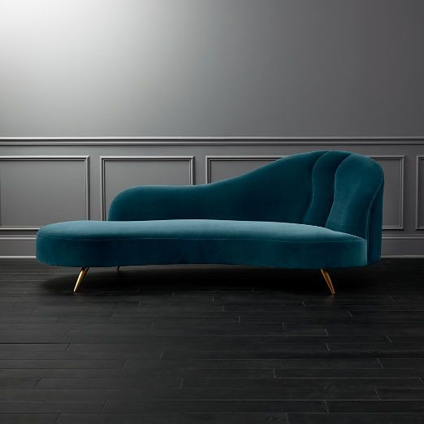

**L-shaped Sofa**

5.L-Shaped Sofa

**Price: $698.99**

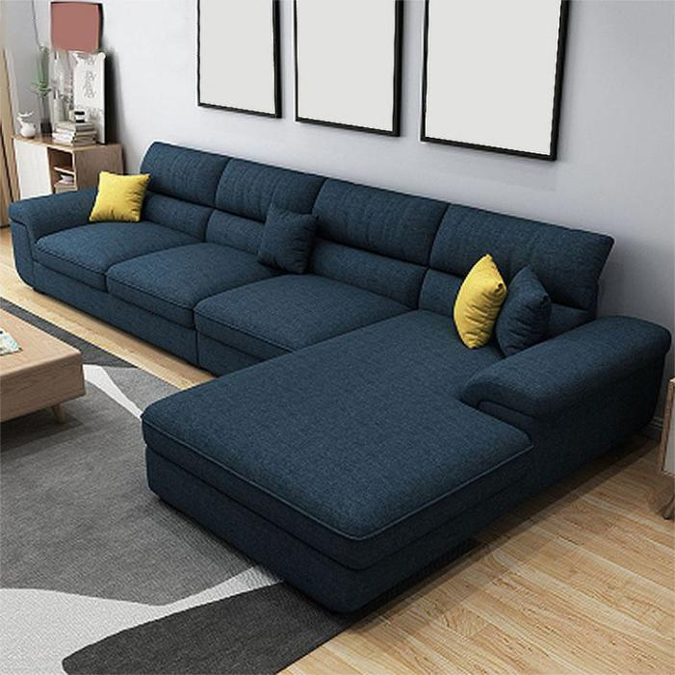

"Indulge in luxury with our L-shaped sectional sofa, a modern twist on classic comfort."

**Price: $698.99**

6.L-Shaped Sofa

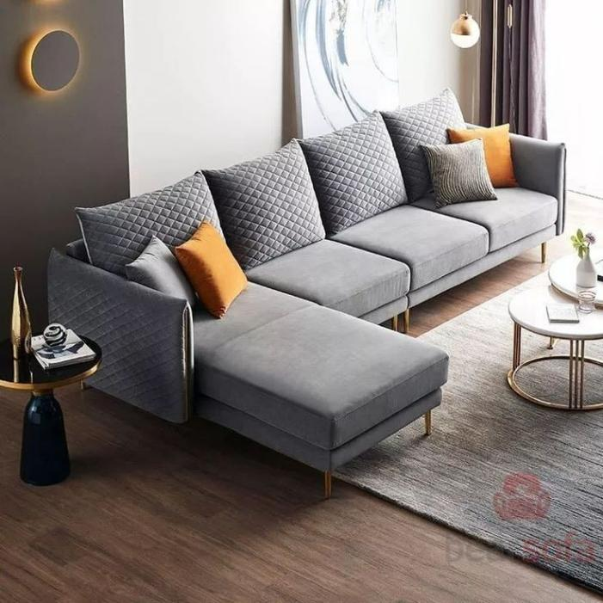

"Indulge in luxury with our L-shaped sectional sofa, a modern twist on classic comfort."

**Price: $698.99**

**Leather Sofa**

7.1 seater leather

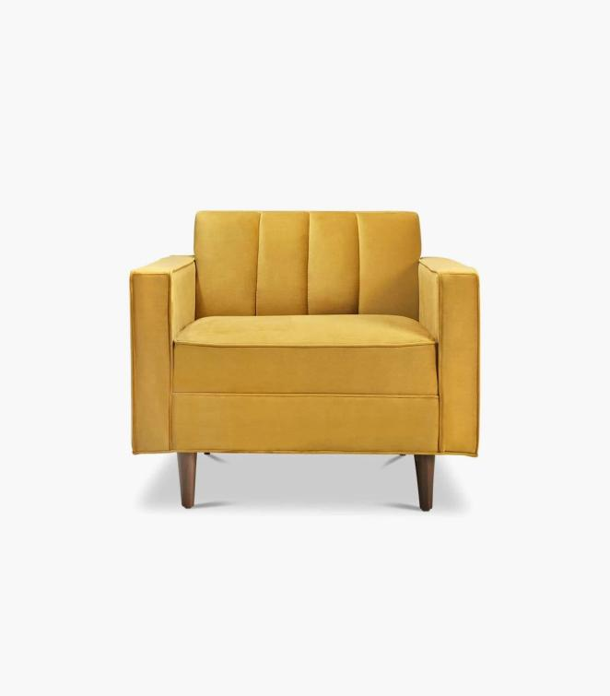

innovative and stylish, our reclining sofa offers personalized relaxation at its finest.

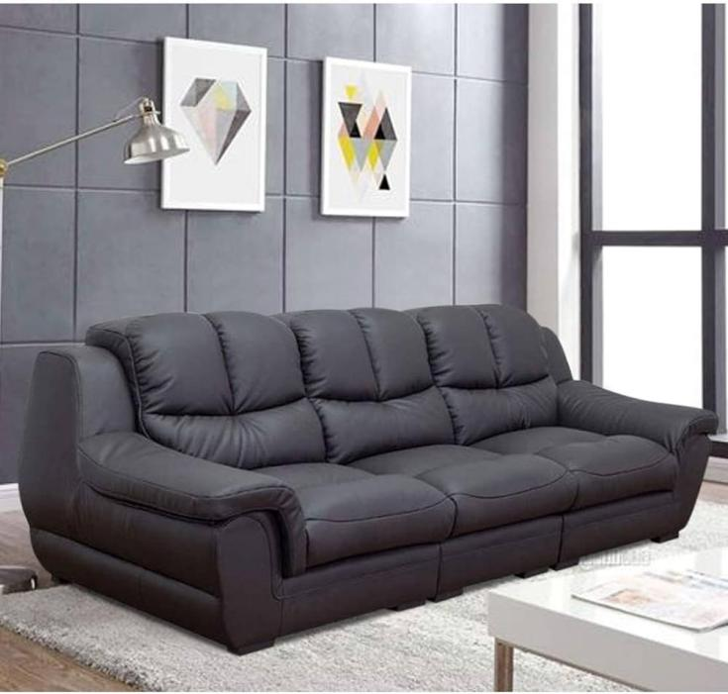

8.Leather black sofa

**Price: $698.99**

innovative and stylish, our reclining sofa offers personalized relaxation at its finest.

**L-shaped Sofa**

**Price: $698.99**

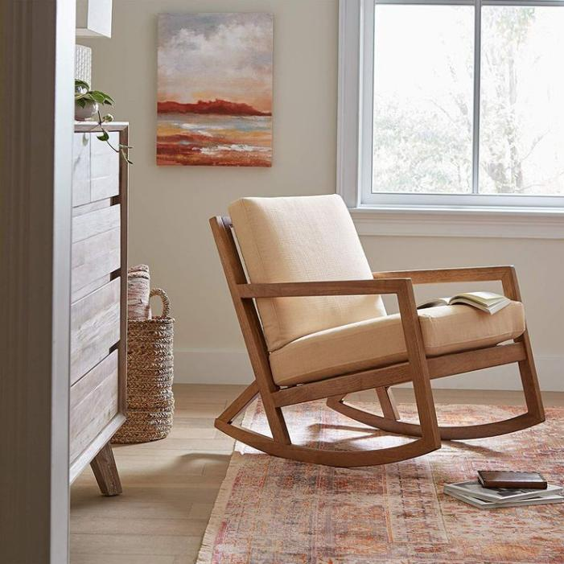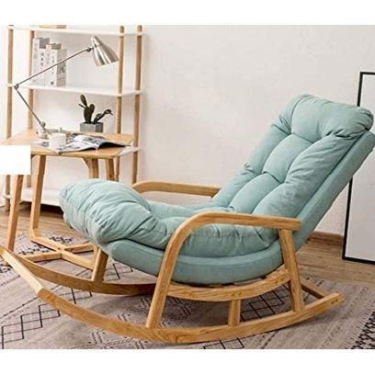

**Rocking Sofa**

9.Rocking Sofa

innovative and stylish, our reclining sofa offers personalized relaxation at its finest.

10.Rocking Sofa 2

**Price: $698.99**

innovative and stylish, our reclining sofa offers personalized relaxation at its finest.

**Price: $698.99**

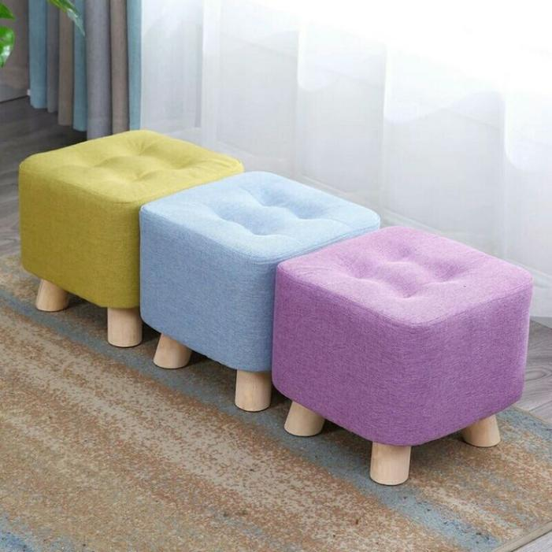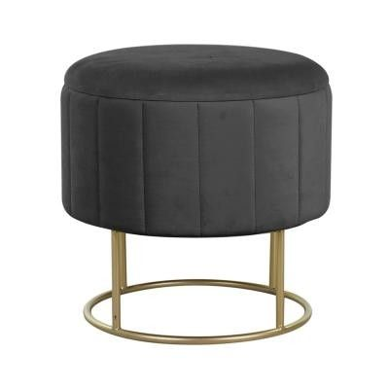

**Sofa Stools**

**L-shaped Sofa**

11.Colorful Sofa Stool

Innovative and stylish, our reclining sofa offers personalized relaxation at its finest.

12.Modern Sofa Stool

**Price: $698.99**

innovative and stylish, our reclining sofa offers personalized relaxation at its finest.

**Price: $698.99**

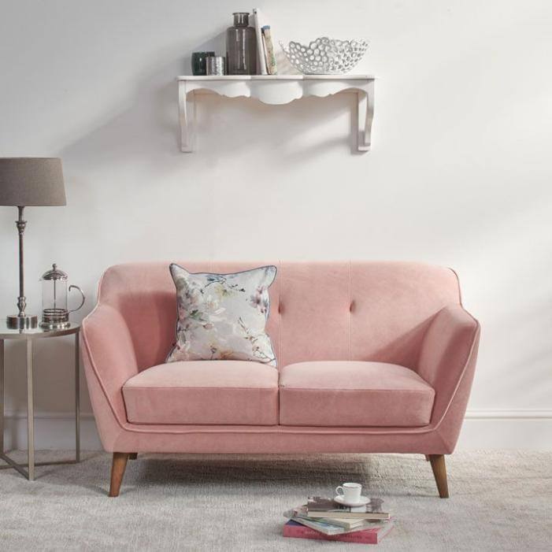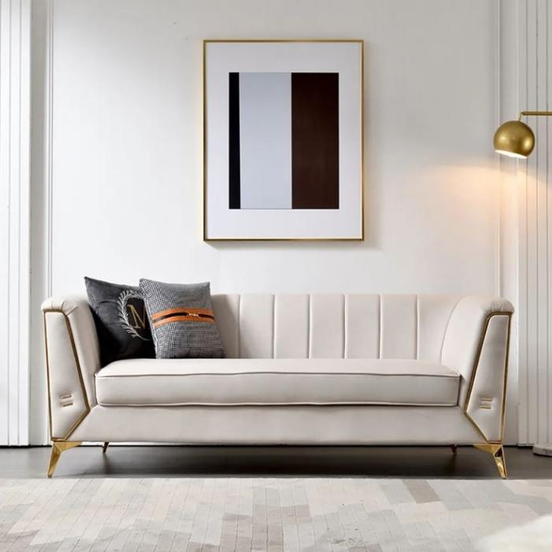

**Seater Sofa**

**L-shaped Sofa**

13.Two Seater Sofa

innovative and stylish, our reclining sofa offers personalized relaxation at its finest.

14.Three Seater Sofa

**Price: $698.99**

innovative and stylish, our reclining sofa offers personalized relaxation at its finest.

**Price: $698.99**

**L-shaped Sofa**

**L-shaped Sofa**